IFIC
Architecture and Execution Flow Version 1.0

Revision History
Rev | Date | Description of Change | By
1.0 | 2025-11-04 | Initial version of document | Darryl Poworoznyk

Table of Contents
Contents
Revision History 1
Table of Contents 2
Table Of Figures 4
Executive Summary 5
System Overview 6
Purpose 6
Major Functions 6
High-Level Architecture 7
External Systems 7
IFIC Core Layers 7
Architecture and Execution flow 8
Overview 8
Execution Sequence 9
Initialization 10
File Detection 11
Parsing 11
Transformation 11
Authentication 12
Submission 12
Response Processing 13
Database Update 13
File Routing 14
Completion 14
Component Responsibility Table 14
Configuration and Integration 15
Configuration Overview 16
Configuration Keys and Purpose 16
Configuration Behavior 18
Folder Structure 18
Mapping Tables 20
Overview 21
Purpose and Function 21
Mapping Location and Schema 21
Runtime Integration 22
Lookup Behavior 23
Benefits 23
Authentication Flow 24
CIHI Submission Integration 26
Overview 26
Workflow Summary 26
Technical Details 27
Error Handling and Logging 28
Data Flow Diagrams 28
Overview 28
Context Diagram 29
Level 1 DFD – High Level Process 29
Flow Summary 29
Error Handling and Logging 31
Error Categories 31
Retry Logic 31
Design Principles 31
Logging and Audit Flow 32
Scalability and Future Enhancements 33
Multi-System Expansion 33
Parallel Processing 33
Enhanced Monitoring 33
CI/CD Pipeline Integration 33
Appendix 34
Folder Definitions 34
Configuration Overview 34
Standards Referenced 34
Summary of Figures 35

Table Of Figures

Figure 1 - IFIC Component Diagram 7
Figure 2 - IFIC Layered Architecture 9
Figure 3 - IFIC Execution Sequence 10
Figure 4 - IFIC Configuration Hierarchy 16
Figure 5 - IFIC Folder Structure 19
Figure 6 - IFIC Authentication and Token Exchange Sequence 25
Figure 7 - IFIC Context Diagram 29
Figure 8 - IFIC Level 1 DFD 30
Figure 9 - Error and Audit Flow 32

Executive Summary

The IRRS/FHIR Intermediary Component (IFIC) is a middleware application developed for VitalHub to enable seamless, secure, and standards-compliant data exchange between Clarity Long-Term Care Facility (LTCF) systems and the Canadian Institute for Health Information (CIHI) through the Integrated Resident Reporting System (IRRS).
IFIC automates the transformation of LTCF assessment data from flat file format into FHIR-compliant XML bundles, performs OAuth2 authentication against CIHI’s secure API gateway, and manages submission responses, database updates, and error handling.
The solution was designed under the CIHI Vendor Certification Framework (2024–2025) and fully conforms to:
- IRRS Reference Manual (FHIR R4 implementation)
- CIHI API Security Guide v1.4 (JWT Client Credentials)

IFIC provides a reliable, auditable, and modular integration layer between VitalHub’s Clarity and the CIHI IRRS submission endpoints.

System Overview

Purpose
IFIC bridges the internal Clarity database and CIHI’s IRRS FHIR interface by:
- Parsing Clarity’s exported LTCF assessment files.
- Mapping each data element to the corresponding FHIR field.
- Constructing Patient, Encounter, and QuestionnaireResponse resources.
- Bundling these resources into a valid FHIR transaction payload.
- Submitting securely via OAuth2 (JWT bearer token).
- Writing submission results and FHIR identifiers back into Clarity.

Major Functions
- File ingestion and validation
- Dynamic field mapping using Excel mapping sheets
- XML construction using strongly typed builders
- OAuth2 authentication and token caching
- FHIR bundle submission and response parsing
- Clarity database update and result tracking
- Automatic folder routing for Queued / Processed / Errored files

High-Level Architecture

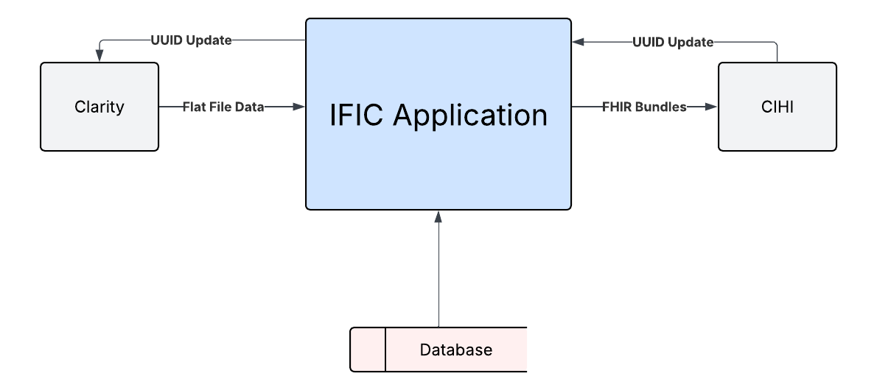
Figure 1 - IFIC Component Diagram

External Systems
- Clarity LTCF: Generates the .dat files for processing and receives the write-backs from IFIC containing the important information from the CIHI response.
- CIHI IRRS API: Receives authenticated FHIR compliant submissions and processes them.

IFIC Core Layers
- Runner Layer: Program.cs, ClarityLTCFUpdateService.cs
- Parsing Layer: FlatFileParser.cs, ParsedFlatFile.cs
- Transformation Layer: BundleXmlBuilder.cs, PatientXmlBuilder.cs, EncounterXmlBuilder.cs, QuestionnaireResponseBuilder.cs, EntryPointResolver.cs
- Integration Layer: AuthManager.cs, IRRSApiClient.cs
- Persistence Layer: ClarityClient.cs, ClarityClientOptions.cs, ElementMapping.cs
- Metadata Layer: AdminMetadata.cs, AdminMetadataKeys.cs

Architecture and Execution flow

Overview
IFIC (Intermediary FHIR Integration Component) is structured as a multi-layered .NET application designed for modularity, maintainability, and interoperability with VitalHub’s LTCF (Long-Term Care Facility) system Clarity.
Each layer isolates a distinct responsibility—parsing, transformation, API integration, and persistence—to simplify maintenance, facilitate testing, and ensure fault tolerance. The system ingests structured flat files exported from Clarity LTCF, partially parses them into typed model objects and/or key valued pairs, transforms those into FHIR-compliant XML or JSON bundles, authenticates with CIHI’s OAuth2 gateway, submits data to the IRRS FHIR endpoint, and writes all submission results back to the local Clarity database.
- The File Ingestion Layer monitors a configured directory for queued flat files and initializes each processing job.
- The Parsing Layer (FlatFileParser) tokenizes sectioned data ([PATIENT], [ENCOUNTER], [SECTION A–N]) into in-memory models such as ParsedFlatFile.
- The Transformation Layer (BundleXmlBuilder, PatientXmlBuilder, EncounterXmlBuilder, QuestionnaireResponseBuilder) maps parsed values into fully compliant FHIR resources using field mapping tables.
- The Integration Layer (AuthManager, IRRSApiClient, CihiResponseParser) handles authentication, submission, and response parsing through CIHI’s REST API.
- The Persistence Layer (ClarityClient) commits results—including generated FHIR IDs, submission timestamps, and errors—back into the Clarity SQL database for audit and retry control.
This layered structure ensures loose coupling between components, enabling developers to test or extend individual functions (for example, supporting JSON payloads or new FHIR resource versions) without disrupting the rest of the system.

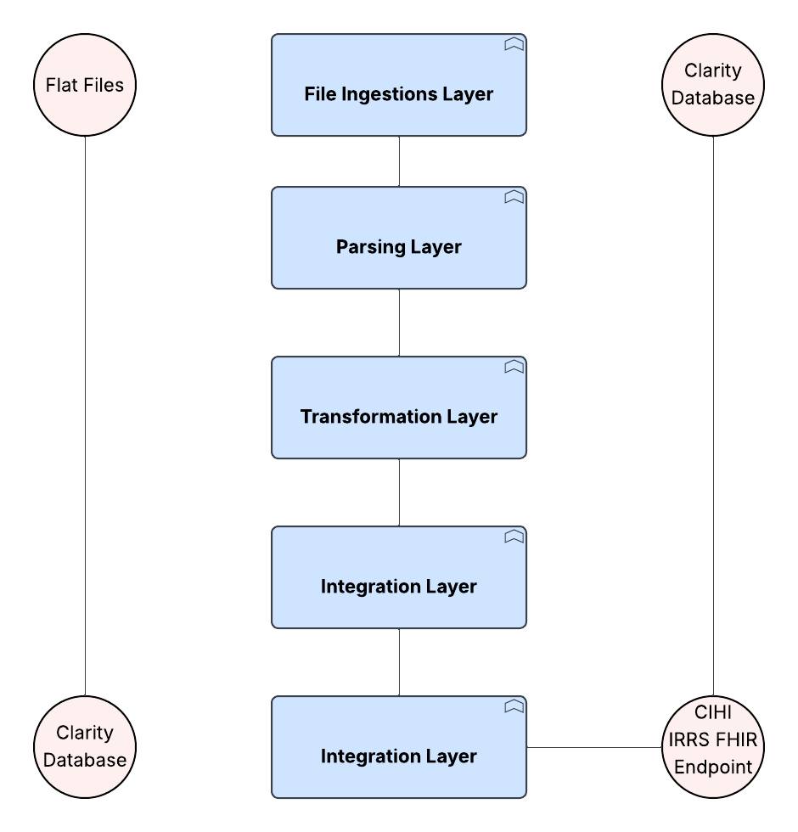
Figure 2 - IFIC Layered Architecture

Execution Sequence
The IFIC (Intermediary FHIR Integration Component) application executes a structured, stepwise workflow that automates the transformation and transmission of LTCF (Long-Term Care Facility) assessment data from the Clarity system to the CIHI IRRS FHIR API. Each phase of execution is designed with clear separation of concerns to ensure traceability, maintainability, and recoverability.
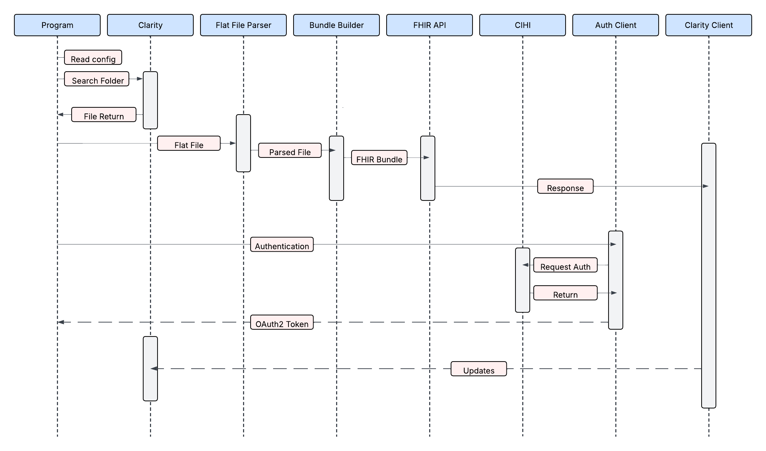
Figure 3 - IFIC Execution Sequence

Initialization
At startup, the Program.cs file initializes the application environment. Configuration settings are read from appsettings.json, which defines:
- TransmitRoot directory paths (Queued, Processed, Errored)
- Database connection string for the LTCF test or production instance
- FHIR base URL for CIHI IRRS endpoint communication
- Key and certificate paths used for OAuth2 token generation
Before proceeding, the system ensures that all logging and working directories exist, creating them dynamically if missing. This guarantees that all runtime events and results are properly recorded for audit and debugging.

File Detection
Once initialized, IFIC begins scanning the Queued directory under the TransmitRoot location for pending data transmission files (typically .dat format).
For each discovered file:
- An instance of ClarityLTCFUpdateService is created to manage the end-to-end processing.
- The file path is passed to the FlatFileParser component for parsing.
This modular design allows multiple queued files to be processed independently in sequence or via future concurrency extensions. If two queued files for one patient, encounter or assessment are in the same run of IFIC the system saves the id from the created resource to use in the next flat file submission.

Parsing
The FlatFileParser reads the LTCF flat file line by line. It detects section headers such as [PATIENT], [ENCOUNTER], and [SECTION A–N], segmenting each portion into logical blocks. The parsed data is assembled into a ParsedFlatFile object containing key–value dictionaries representing all fields within each section. Before transformation, the parser validates that mandatory sections exist and that critical identifiers (e.g., OrgID, A3 - Birth Date, B2 - Encounter ID) are present. Any missing or malformed data triggers early validation errors, preventing invalid bundle submissions.

Transformation
Once parsing is complete, the BundleXmlBuilder component orchestrates the construction of FHIR-compliant XML resources.
It delegates to specialized sub-builders:
- PatientXmlBuilder – generates the FHIR Patient resource using demographic and identifier data from [PATIENT].
- EncounterXmlBuilder – builds the FHIR Encounter resource from [ENCOUNTER].
- QuestionnaireResponseBuilder – constructs a section-by-section QuestionnaireResponse based on the assessment data [SECTION A–N].
The EntryPointResolver component assembles the three FHIR resources into a cohesive FHIR Bundle (type = transaction). Each <entry> element is appended with an HTTP <request> directive defining POST operations and target resource URLs. The resulting XML document is serialized to a temporary file structure for subsequent submission and logging.

Authentication
The AuthManager handles security and credential management. It creates a JWT (JSON Web Token) using the configured private key and metadata from appsettings.json. The token is exchanged with CIHI’s OAuth2 token endpoint to obtain a Bearer access token used for authenticated API calls. For efficiency, tokens are cached in memory until expiry, reducing redundant authentication requests during batch operations.

Submission
The IRRSApiClient initiates the transmission of the constructed FHIR bundle to the CIHI IRRS endpoint (/irrs-service/fhir).
For each submission:
- The XML payload is posted via HTTPS using the access token in the Authorization: Bearer header.
- A unique request identifier is logged alongside timestamps and response status.
All data is sent securely over an encrypted connection, and the system can automatically retry submissions or wait briefly before trying again if there are temporary network problems.

Response Processing
After CIHI processes the bundle, IFIC captures the full API response.
The CihiResponseParser extracts and interprets:
- FHIR resource identifiers (Patient, Encounter, QuestionnaireResponse IDs)
- Submission status codes (success, validation error, or partial failure)
- Detailed error messages from CIHI if any sections were rejected
Errors are categorized as:
- Validation errors: schema or content mismatches
- Connectivity errors: network or SSL failures
- Authentication errors: expired or invalid tokens
All results are logged in structured JSON format for traceability.

Database Update
Using the ClarityClient, IFIC connects to the LTCFTest SQL database through parameterized queries or stored procedures.
It updates:
- Submission statuses
- FHIR resource identifiers returned from CIHI
- Associated timestamps and error messages
This ensures that the Clarity LTCF application can display real-time submission results and retry failed records with full context.

File Routing
After database updates:
- Files that were successfully transmitted and acknowledged by CIHI are moved to the Processed folder.
- Files that failed any stage (validation, authentication, or network) are relocated to the Errored folder, with timestamped filenames and detailed log files generated alongside them.
This routing mechanism supports automated reprocessing and audit review.

Completion
At the end of each run, IFIC records detailed log entries for each step of the process, including which files were processed, whether each succeeded or failed, and any related error messages. While it does not yet create a formal summary report, the logged information can be easily reviewed or extended in the future to include a daily summary, retry schedule, or integration with an external monitoring tool.

Component Responsibility Table

Layer | Component | Description | Input | Output | Dependencies
Runner | Program.cs | Entry point: Initializes services and orchestrates run | Config | Workflow summary | .NET DI, Logging
Runner | ClarityLTCFUpdateService.cs | Central controller for each file | File path | Submission result | FlateFileParser, BundleXMLBuilder, IRRSApiClient, ClarityClient
Parsing | FlatFileParser.cs | Reads and tokenizes flat file sections | .dat file | ParsedFlatFile | —
Parsing | ParsedFlatFile.cs | Model representing parsed sections | Section text | Structured data | —
Transformation | BundleXmlBuilder.cs | Builds complete FHIR bundle | ParsedFlatFile | XML string | Patient/Encounter/QR builders
Transformation | PatientXmlBuilder.cs | Constructs <Patient> element | Patient section | XML node | Mapping tables
Transformation | EncounterXmlBuilder.cs | Constructs <Encounter> | Encounter section | XML node | Mapping tables
Transformation | QuestionnaireResponseBuilder.cs | Builds QuestionnaireResponse | Sections A–N | XML node | Mapping tables
Transformation | EntryPointResolver.cs | Adds <request> entries for FHIR transaction | XML nodes | XML | AdminMetadata
Integration | AuthManager.cs | Handles JWT and token acquisition | Private key | Access token | CIHI Auth API
Integration | IRRSApiClient.cs | Submits bundle to CIHI | XML, token | HTTP response | AuthManager
Persistence | ClarityClient.cs | Writes results back to Clarity DB | Status, IDs | DB update | SQL Server
Persistence | ElementMapping.cs | Reads Excel mappings | Excel path | Mapping dictionary | EPPlus / OpenXML
Metadata | AdminMetadata.cs | Holds OrgID, AssessmentID, EncounterID | Config + File data | Metadata object | —

Configuration and Integration

Configuration Overview
The Intermediary FHIR Integration Component (IFIC) is designed for portability and maintainability across multiple deployment environments, including Development, Test, and Production without requiring code changes or recompilation. This flexibility is achieved through a single centralized configuration file: appsettings.json.
The configuration file controls all runtime parameters such as directory paths, database connections, authentication credentials, and API endpoints. By externalizing these values, IFIC separates environment-specific settings from its compiled logic, ensuring that the same executable can be safely deployed in different environments by simply replacing the configuration file.
The configuration file follows a hierarchical structure aligned with .NET conventions. Each major subsystem such as ClarityClient, Authentication, and FHIR defines its own child section within appsettings.json, grouping related parameters under descriptive keys. This organization promotes clarity and simplifies automated deployment, backup, and auditing of configuration changes.

Configuration Keys and Purpose
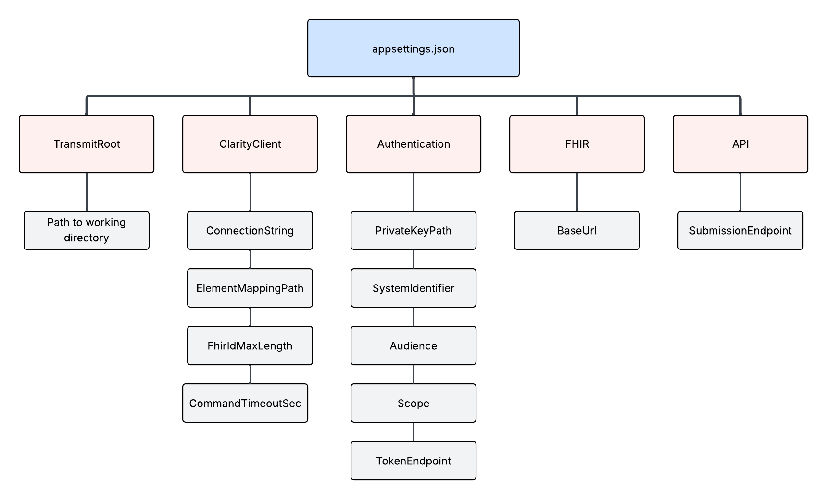
Figure 4 - IFIC Configuration Hierarchy

Section | Key | Purpose / Description
TransmitRoot | Path to working directory  (e.g., C:\\Clarity\\Transmit\\LTCFTransTest) | Defines the root directory under which IFIC manages its Queued, Processed, and Errored subfolders. This location determines where incoming flat files are detected and where processed results are stored.
ClarityClient.ConnectionString | SQL connection string | Specifies the database connection used to write submission results, FHIR identifiers, and error messages back to the LTCFTest or production SQL database.
ClarityClient.ElementMappingPath | Path to Excel mapping file | Points to the mapping file (e.g., Patient_Mapping_Table.xlsx, Assessment_Mapping_Table.xlsx) that defines field-to-FHIR element relationships and error code mappings.
Authentication.PrivateKeyPath | File path to PEM private key | Identifies the private key used to sign the JWT during the OAuth2 client-credential exchange with CIHI.
Authentication.SystemIdentifier | OAuth2 client ID | The unique system identifier assigned by CIHI for IFIC’s registration. It identifies IFIC as a trusted client when requesting access tokens.
Authentication.Audience | Token audience | Specifies the token audience URI (always https://auth.api.cihi.ca/gateway/oauth/token) that CIHI uses to validate issued tokens.
FHIR.BaseUrl | FHIR server root URL | Defines the base endpoint for the CIHI IRRS FHIR API. For the VitalHub test environment, this is typically https://vt.api.cihi.ca/irrs-service/fhir.
Api.SubmissionEndpoint | Optional submission endpoint override | Used when submission URLs differ from the FHIR base (for example, internal routing or simulation endpoints). If not provided, defaults to FHIR.BaseUrl.

Configuration Behavior
At runtime, Program.cs loads all configuration values into memory using the built-in .NET configuration provider. This allows downstream components such as AuthManager, IRRSApiClient, and ClarityClient to reference their respective configuration sections through dependency injection or direct lookup.
For example:
- The AuthManager reads Authentication.PrivateKeyPath, SystemIdentifier, and Audience to build the JWT and request authorization from CIHI’s OAuth2 Token Service.
- The IRRSApiClient reads FHIR.BaseUrl and Api.SubmissionEndpoint to post the generated FHIR bundles.
- The ClarityClient retrieves the ConnectionString and ElementMappingPath to log submission results and error mappings.
This modular approach ensures that sensitive values such as database credentials and private keys remain outside the compiled binary and can be rotated or replaced without modifying the code.

Folder Structure
The IFIC application operates within a clearly defined directory hierarchy, typically under the path:
C:\Clarity\Transmit\LTCFTransTest
This root folder—configured through the TransmitRoot setting in appsettings.json—serves as the working directory for all input, output, and log operations performed during submission cycles.
IFIC monitors and manages subfolders within this directory to ensure that every data file follows a consistent lifecycle from ingestion to archival.
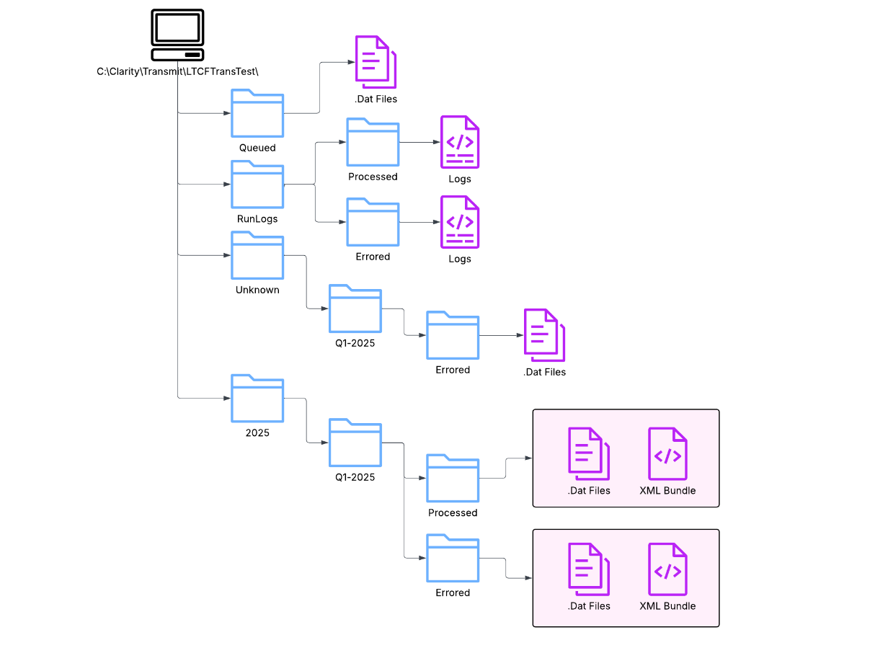
Figure 5 - IFIC Folder Structure
Folder | Purpose | Behaviour
Year Folder | Serves as a top-level container grouping all quarterly processing for a single calendar or fiscal year. | Created automatically at the start of each year or during deployment if not already present.  Keeps annual data separated for compliance and retention policies.
Unknown Folder | Used for unknown errors that happen | Uses a Quarter folder and an Errored Folder to store the .dat file of the errored submission.
RunLogs Folder | To save the FHIR responses | Has both processed and Errored folders and saves the FHIR response according to whether it is an error of some sort or a valid response containing the new ids.
Queued Folder | Entry point for all new .dat files generated by the Clarity LTCF system.  IFIC continuously monitors this folder for pending submissions. | When a file is detected, it is locked for processing and removed for transmitting. If the file fails transmission it does not stay in this folder.
Quarter Folder | Groups all submissions, Processed and Errored for (Q1, Q2, Q3, Q4). | Created automatically or manually as part of quarterly rollovers.  Each quarter contains its own full set of operational subfolders ( Processed, Errored).
Processed Folder | Stores successfully transmitted files confirmed by CIHI’s FHIR endpoint. | Files are grouped by processing date and time. Contains the .dat file and the xml bundle file that was sent.
Errored Folder | Holds files that failed any stage of processing parsing, transformation, authentication, or submission. | Files are grouped by processing date and time. May contain the .dat file and/or the xml bundle file that was sent.

Mapping Tables

Overview
IFIC now relies on a single Excel mapping file “Error-Element-Mapping.xlsx” to translate internal interRAI or CIHI codes (such as iA9, R7, or iU2) into database-specific context and user-friendly descriptions. This mapping mechanism provides a consistent bridge between low-level technical identifiers and meaningful human-readable data, without requiring any code changes when mappings evolve. It ensures that validation errors, transformation exceptions, and database update issues are all expressed using a unified naming convention that is clear to both technical and non-technical stakeholders.

Purpose and Function
During CIHI FHIR submissions or local database updates, IFIC may encounter codes or keys that represent specific elements within a patient assessment record. These codes originate from the LTCF assessment schema and are used throughout parsing, validation, and response handling.
The ElementMapping class (implemented in IFIC.ClarityClient) is responsible for:
- Loading the mapping definitions from the Excel file into memory.
- Resolving each interRAI/CIHI code (iA9, R7, B1, etc.) into:
  - The corresponding database section (e.g., Section_A, Section_R),
  - The element code (for display and FHIR tracing),
  - The human-friendly element name (for logs, UIs, or reports).
This allows IFIC to automatically link every validation or transactional error to its descriptive context — for example:
- iA9 -> Section A, Code A9, Element Name Date of Birth
- iU2 -> Section U, Code U2, Element Name Assessment Reference Date

Mapping Location and Schema
The mapping file path is configured in appsettings.json as shown below:
"ClarityClient": {
"ElementMappingPath": "Mappings/Error-Element-Mapping.xlsx"
}

The workbook contains a single worksheet named elementMap, which defines three key columns shown in the table below.
Column | Description
iCodeName | Canonical interRAI or CIHI element key (e.g., iA9, iU2, B1).
elementName | Human-readable label or display name for the field.
Section | CIHI section identifier (e.g., A9, R7, S2).
The file can be updated independently of the application and any future schema or code additions from CIHI can be reflected by editing the spreadsheet rather than recompiling code.

Runtime Integration
At startup, the ElementMapping constructor loads Error-Element-Mapping.xlsx using the ClosedXML library. Each row is parsed and stored in a case-insensitive dictionary that maps every iCodeName (and its alternate prefix forms) to a tuple containing:
- Section letter (A–Z)
- Element code (e.g., R7, A9a)
- Element display name
Alternate prefixes such as iA5a and cihiA5a are automatically normalized, ensuring compatibility between legacy and CIHI naming conventions.
During execution:
- ClarityClient uses the mapping whenever it processes validation or database exceptions.
It resolves the error’s iCode to display text and logs it for traceability.
- Database update routines store both the code and the descriptive label for downstream auditing.
- Run logs include mapped element names for readability when diagnosing data issues.
This mapping process is read-only and does not alter the Excel file; all lookups are performed from memory for maximum efficiency.

Lookup Behavior
The lookup logic is exposed through the method:
bool TryResolveICode(string iCode, out string sectionLetter, out string elementCode, out string elementName);

It performs constant-time lookups using the in-memory dictionary.
Example Usage:
if (mapping.TryResolveICode("iA9", out var section, out var code, out var name))
{
// section = "A"
// code = "A9"
// name = "Date of Birth"
}
This enables the ClarityClient to enrich logs, database updates, and error messages with contextual metadata about each field involved in an issue.

Benefits
Benefit | Description
Traceable Error Handling | All CIHI and database errors can be linked back to a standardized element name and section.
Maintainability | Field mappings are externalized to Excel; schema changes do not require code updates.
Performance | Mappings are pre-loaded into memory for fast, low-latency lookups.
Consistency | The same element identifiers and names appear in logs, database audit tables, and submission metadata.

Authentication Flow
The IFIC system authenticates with the CIHI IRRS FHIR API using an OAuth 2.0 Client Credentials Grant that employs a JWT assertion signed with a private RSA key. This design ensures secure, stateless authentication for machine-to-machine transactions and adheres to the CIHI API Security Guide v1.4. Authentication is handled entirely by the AuthManager class, which prepares and signs a short-lived JSON Web Token (JWT) using the organization’s private key, exchanges it for an access token from CIHI’s authorization server, and provides that token to downstream components such as IRRSApiClient.
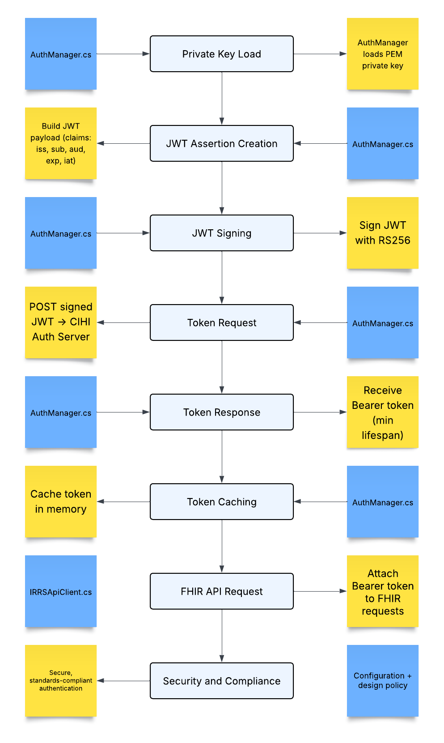
Figure 6 - IFIC Authentication and Token Exchange Sequence

CIHI Submission Integration

Overview
Once authentication has been successfully completed, the IFIC system submits patient assessment data to CIHI’s IRRS FHIR endpoint:
https://vt.api.cihi.ca/irrs-service/fhir
Each submission is a FHIR Bundle resource with type="transaction", containing a complete set of related resources for a single record transmission — typically a Patient, Encounter, and QuestionnaireResponse. This ensures that all dependent records are processed atomically as one logical unit by CIHI’s FHIR server.

Workflow Summary
Step | Component / File | Description
1. Bundle Construction | BundleXmlBuilder.cs orchestrates three resource builders:  – PatientXmlBuilder → builds the Patient entry  – EncounterXmlBuilder → builds the Encounter entry  – QuestionnaireResponseBuilder → builds the QuestionnaireResponse entry | Each resource includes an internal <request> block defining its operation (POST, PUT, or DELETE) and relative URL, as required by FHIR transaction Bundles.
2. Bundle Validation | BundleXmlBuilder + ParsedFlatFile models | The bundle is validated to ensure all mandatory sections are populated and XML is well-formed before submission. Optional simulation mode writes the generated XML to disk for testing.
3. HTTP Submission | IRRSApiClient.cs | Performs an authenticated POST to the configured CIHI FHIR endpoint using the token from AuthManager.  Headers include:  Content-Type: application/fhir+xml  Authorization: Bearer {token}  Timeouts, retries, and correlation IDs are managed within this component.
4. Synchronous Response | IRRSApiClient.cs | CIHI returns a synchronous HTTP response — 200 OK for success or 4xx/5xx for validation or system errors. The response body is a FHIR Bundle of type transaction-response containing <entry> elements and optional OperationOutcome resources.
5. Response Parsing | CihiResponseParser.cs | Extracts the assigned resource IDs (Patient/xxxx, Encounter/xxxx, QuestionnaireResponse/xxxx) from <response><location> nodes.  Any OperationOutcome issues are captured for error logging and reporting.
6. Database Update | ClarityClient.cs | Updates the LTCFTest database with the submission status, returned FHIR IDs, and any error messages. This ensures synchronization between the local system and CIHI.
7. File Routing | Runner.cs | On success, the processed file is archived to Processed/YYYYMMDD_TIMESTAMP/; on failure, it is moved to Errored/ with its log entry.

Technical Details
FHIR Bundle Structure
- Type: transaction
- Entries:
  - Patient resource – identifies the resident/client.
  - Encounter resource – describes the episode of care or admission context.
  - QuestionnaireResponse resource – holds the assessment answers (A–N sections).
- Each entry contains a <request> element such as:
<request>
<method value="POST"/>
<url value="Patient"/>
</request>
- The three entries together ensure referential integrity and atomic submission.
Authentication and Security
All submissions include a valid Bearer token retrieved from AuthManager.
Requests are transmitted via TLS 1.2 or higher, and the system never logs tokens or personal health information.

Error Handling and Logging
If CIHI returns an OperationOutcome or a non-200 HTTP status, CihiResponseParser categorizes the issue:
- Validation errors (e.g., missing fields or invalid codes)
- Connectivity errors (e.g., timeout, network failure)
- Authentication errors (e.g., expired token)
ClarityClient writes the details to the log and updates the submission status in the database.
This allows full traceability of every FHIR transaction through file status, database record, and log file.

Data Flow Diagrams

Overview
This section illustrates how data travels through the IFIC pipeline — from the arrival of a flat file to submission, database update, and archival. The diagrams below provide both a high-level overview (Level 1) and a detailed breakdown (Level 2) to complement the narrative in the previous section Configuration and Integration.

Context Diagram
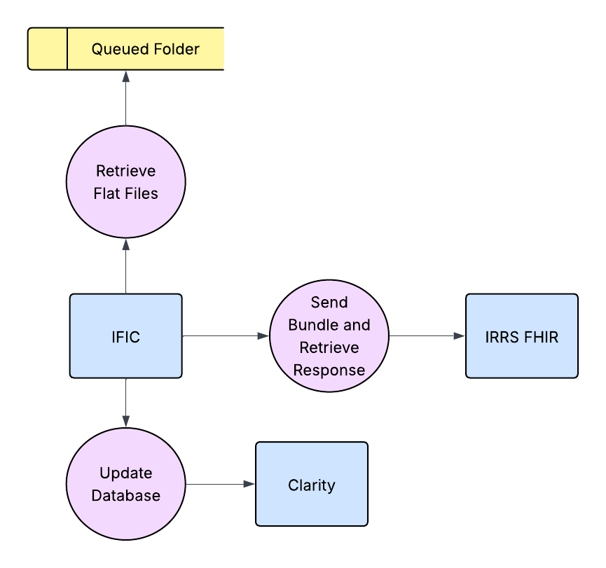
Figure 7 - IFIC Context Diagram

Level 1 DFD – High Level Process

Flow Summary
- Iterate Files (Runner / FileIngestor)
Detects .dat files in the Queued directory and initiates processing.
- Setup AuthManager
Initializes the authentication module and loads configuration values from appsettings.json.
- Parse Flat File (FlatFileParser)
Reads [PATIENT], [ENCOUNTER], and [SECTION A–N] blocks and populates a structured ParsedFlatFile object.
- Build Bundle (BundleBuilder)
Constructs a FHIR Bundle (type = transaction) containing Patient, Encounter, and QuestionnaireResponse entries.
- Request Token (AuthManager)
Generates and signs a JWT, then requests an OAuth2 Bearer token from CIHI.
- Submit FHIR Bundle (IRRS API Client)
Sends the XML Bundle to the CIHI FHIR endpoint and waits for a synchronous response.
- Parse Response Bundle (CIHI Response Parser)
Extracts resource IDs and any OperationOutcome diagnostics from CIHI’s reply.
- Update Clarity Database (Clarity Client)
Writes submission status, FHIR IDs, and error text to the LTCF database.
- File Routing
Routes files to Processed or Errored folders based on submission outcome, ensuring audit traceability.
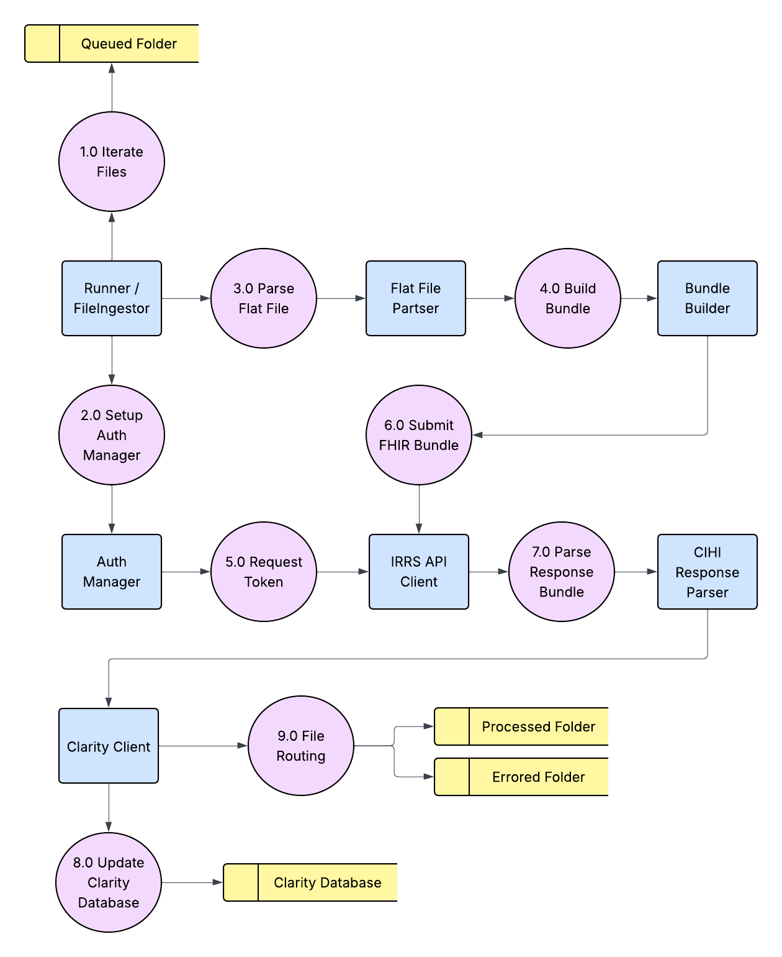
Figure 8 - IFIC Level 1 DFD

Error Handling and Logging

Error Categories
IFIC captures and classifies all exceptions and API responses into consistent categories. Each type of failure is associated with a recovery or escalation action.
Error Category | Description | Action Taken
Validation | Missing or invalid field in the source file | Logged and file marked as FAILED; not retried
Authentication | OAuth2 token invalid or expired | Retried once after 10 seconds
Transmission | Network timeout or unreachable endpoint | Retried once; moved to Errored if persistent
FHIR Business Rule | CIHI OperationOutcome error returned | Logged with mapped element description; manual correction required
Database | SQL constraint or connection error | Logged; file remains Errored
Unknown | Any unhandled runtime exception | Logged as critical for manual investigation

Retry Logic
IFIC operates as a deterministic file-processing system meaning each .dat file represents a fixed data snapshot from Clarity. Because validation errors generally stem from user-entered data rather than transient issues, automatic retries are deliberately limited. This approach prevents repeated submission of invalid data while still tolerating brief connectivity issues.

Design Principles
- No automatic retries for validation, FHIR, or database errors. These require user correction in Clarity, which triggers the generation of a new flat file for resubmission.
- Token renewal is handled automatically within AuthManager when a token expires or fails authentication.
- Transmission errors (e.g., timeout or network interruption) may optionally be retried once after a short delay (≈10 seconds).
- All outcomes, including transient or fatal errors, are logged in RunLogs and reflected in the database for full traceability.

Logging and Audit Flow
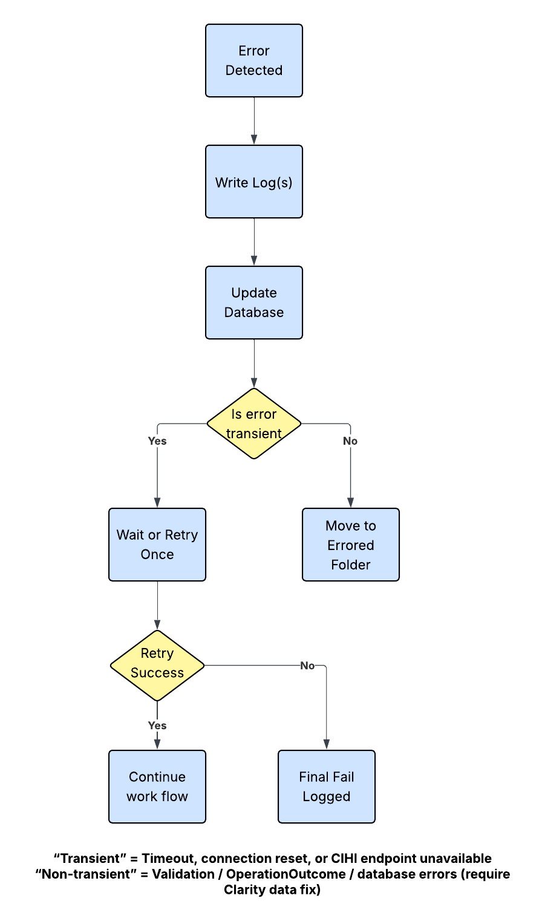
Figure 9 - Error and Audit Flow

Scalability and Future Enhancements

Multi-System Expansion
IFIC’s architecture is modular and already validated for the Clarity LTCF implementation. The same transformation and submission core can extend to other VitalHub systems:
System | Integration Status | Notes
Clarity | Implemented | Production-ready; CIHI certified
TREAT | Not yet planned | Requires custom mapping and full integration
B Care | Not yet planned | Requires custom mapping and full integration

Parallel Processing
Future versions may support multi-threaded ingestion for high-volume LTCF submissions:
- Thread-safe queue for parallel file parsing and submission
- Shared token cache to minimize authentication overhead
- Configurable max parallel submissions per environment (dev/test/prod)

Enhanced Monitoring
Planned enhancements include:
- Real-time metrics dashboard showing submission success rate and latency
- Integration with Windows Event Viewer or centralized logging (e.g., Elastic Stack)
- Automatic email alert on consecutive submission failures

CI/CD Pipeline Integration
Continuous Deployment integration will ensure:
- Automated build and unit test using GitHub Actions or Azure DevOps
- Environment-specific configuration deployment
- Automated regression testing for CIHI schema changes

Appendix

Folder Definitions

Folder | Purpose
Queued | Stores pending .dat files awaiting submission to CIHI.
Processed | Contains successfully transmitted and archived submission files.
Errored | Holds files that failed validation, transformation, or CIHI submission and require manual review or correction in Clarity.
RunLogs | Contains timestamped log files generated for each IFIC execution run, detailing processing, submission, and audit results.

Configuration Overview
All configuration parameters for IFIC are settable in the application’s appsettings.json file, enabling seamless deployment across development, test, and production environments without recompiling.
Adjustable parameters include:
- Folder structure and working root directory
- Database connection strings
- OAuth2 authentication credentials and token endpoints
- FHIR base URL and submission endpoints
- Mapping file and private key references
This design ensures portability, environment isolation, and simplified maintenance for administrators and deployment engineers.

Standards Referenced
- OAuth 2.0 Client Credentials Grant — RFC 6749
- JWT Bearer Assertion — RFC 7523
- RS256 Signature Algorithm — RFC 7518
- HL7 FHIR Release 4 Specification
- CIHI IRRS FHIR Implementation Guide v1.4

Summary of Figures

Figure | Title | Purpose / Description
Figure 1 | IFIC Component Diagram | High-level view of major modules (File Ingestor, Parser, Transformers, Auth, API Client, Database Updater) and their interactions.
Figure 2 | IFIC Layered Architecture | Depicts logical separation between presentation, transformation, integration, and persistence layers.
Figure 3 | IFIC Execution Sequence | Step-by-step sequence of events from file detection to CIHI submission and completion.
Figure 4 | IFIC Configuration Hierarchy | Shows how configuration values (authentication, API, FHIR, mapping, database) relate within appsettings.json.
Figure 5 | IFIC Folder Structure | Visual representation of the runtime folder organization (Queued, Processed, Errored, RunLogs).
Figure 6 | IFIC Authentication and Token Exchange Sequence | Details how AuthManager generates, signs, and exchanges JWTs for CIHI OAuth2 tokens.
Figure 7 | IFIC Context Diagram | Illustrates system boundaries — interaction between Clarity, IFIC, and CIHI.
Figure 8 | IFIC Level 1 Data Flow Diagram | High-level process view showing flow from file ingestion to CIHI submission and database update.
Figure 9 | Error and Audit Flow | Shows error detection, limited retry for transient failures, database status updates, and log routing.

